Table of Contents
1. Introduction 2
2. Image Model Training 3
3. Material Selection 5
3.1 3D Printing Material 5
3.2 Material for Outer Case 5
4. Inner Holder 6
5. Outer Case 6
6. Final Assembly 8
7. Design Studies 9
7.1 Static Study 9
7.2 Drop Test 10
8. Financial 11
9. References 13
10. Appendixes 14
Appendix A: Dimensions for outer casing 14

Introduction
The goal of this project is to create a solar-powered device that can detect elephants in real time using audio and visual AI detection. The weatherproof, impact-resistant designed device is intended for outdoor deployment and acts as an early warning system to reduce conflicts between humans and elephants. The solution reduces the need for a powerful internet connection by processing data locally on an edge device, guaranteeing quicker response times and increased dependability in remote areas.
However, the system has certain limitations. The device’s detection accuracy is influenced by the quality and quantities of the training data and the settings for training. The environmental conditions such as lighting, weather, and background noise at the deployment location could also affect the detection accuracy. The device is specifically trained to detect elephants and may not effectively differentiate other objects or wildlife species as there are limited datasets for other classes to be detected. Additionally, the extreme weather conditions and power constraints could impact its continuous operation, requiring further optimizations for long-term field deployment.
This project aims to deliver a fully functional prototype integrating both image and audio-based detection capabilities. The AI models will be trained to recognize elephants with high accuracy while maintaining reasonable accuracy for other included classes. The system will transmit detection data, including timestamp, confidence level, images and audio recordings, to a database via an API and display the information on a dedicated website.
The implementation of this system brings significant social and economic benefits. Socially, it helps reduce human-elephant conflicts, preventing injuries and damaging plantation areas while promoting peaceful coexistence. Farmers and local communities can better protect their crops and property, leading to improved livelihoods.
Economically, the system helps minimize agricultural losses caused by elephant intrusions, reducing the financial burden on farmers. It also decreases the need for costly physical barriers and human patrols, making it a cost-effective solution for wildlife management.

Image Model Training
For the device to detect elephants on an edge device in real time, the algorithm needs to be lightweight and computationally efficient. YOLO was chosen as the detection algorithm because of its small model size and fast processing speed [1]
A dataset with a total of $13,436$ images are used in the image model training. $80\%$ of the images are images with elephants and the remaining are images with other objects such as humans, cars, cows, etc. The images obtained from university and MEME are annotated locally to maintain the confidentiality of the data. The other images are obtained from public projects on Roboflow website.
A Python script is used to randomly split the dataset into three folders: "train," "validation," and "test" in proportions of 70%, 20%, and 10%, respectively. The images in the train folder are used to train the detection model, while those in the validation folder help assess the model's accuracy during training. The images in the test folder are not exposed to the model during training and are used to evaluate the final trained model's accuracy.
Another Python script is used to train the image detection model using a pretrained YOLOv11 weight. Several parameters are configured for training, including setting the image size to 640 pixels and applying a 20% probability of flipping images during training to improve the model's ability to detect flipped objects.
The number of epochs refers to how many times the entire training dataset is processed during training. While a higher number of epochs may cause overfitting, too few epochs can lead to underfitting [2]. The image detection model is trained for up to $500$ epochs, with early stopping triggered if no improvement is observed after $100$ epochs.

Material Selection

3.1 3D Printing Material
3D printing is an additive manufacturing method that can create complex sculptural bodies quickly and affordably [4]. The inner holders for mounting the components are 3D printed using PETG (Polyethylene Terephthalate Glycol) filament.
PETG is compared with two other prominent 3D printing materials, namely PLA and ABS. The material of the inner holder should be light in weight, weatherproof and have a high tensile strength. Table 3.1.1 shows the comparison of the properties of the three filaments.
Table 3.1.1: Comparison between PLA, ABS and PETG [5].
Properties | PLA | ABS | PETG
Density $(g/cm^{3})$ | $$1.25$$ | $$1.04$$ | $$1.23$$
Tensile Strength $(MPa)$ | $$65$$ | $$43$$ | $$49$$
Flexural Strength $(MPa)$ | $$97$$ | $$66$$ | $$70$$
Extrusion Temperature $(°C)$ | $$190-210$$ | $$220-260$$ | $$230-250$$
Recyclability | Yes | Yes | Yes
Biodegradability | Yes | No | No
Flume Toxicity | Less | Medium | Less
From Table 3.1.1, among the three materials analyzed, PETG exhibits a well-balanced set of properties, giving a moderate performance relative to the other options. PETG is characterized by high chemical resistance, toughness, and a combination of ductility, transparency, and resistance to both chemicals and impact [5]. Among these three materials, PETG is the most resistant material based on tensile test experiment result [6].
In terms of environmental impact, ABS, a petroleum-based plastic, has the highest overall environmental impact, particularly in manufacturing and recycling, due to its material properties [7]. PETG has the lowest environmental impact across all parameters, making it the most sustainable choice. Compared to PLA, PETG performs slightly better in terms of human health and resource consumption [7]. However, PLA has a significantly higher negative impact on ecosystem quality, second only to ABS [7].
Due to PETG’s moderate performance across key criteria and its suitability for the intended application, it has been selected as the preferred option.

3.2 Material for Outer Case
The outer case is manufactured from a 2mm thick 6061-O aluminum alloy sheets to achieve a lightweight casing design while having the strength to hold components. The 6061-O aluminum alloy sheet also provides high tensile strength, resistance to corrosion, etc. Table 3.2.1 shows the properties of a 6061-O aluminum alloy.
Table 3.2.1: Properties of 6061-O aluminum alloy [8].
Density | $$2700 kg/m^{3}$$
Ultimate Tensile Strength | $$310 MPa$$
Modulus of Elasticity | $$68.9 GPa$$
Poisson’s Ratio | 0.33
Fatigue Strength | $$96.5 MPa$$
Thermal Conductivity | $$167 W/(mK)$$
From Table 3.2.1, 6061-O aluminum alloy has high tensile strength and fatigue strength while having a low density of $2700 kg/m^{3}$. Aluminum in general also offers high resistance to corrosion due to its tendency to form an oxide layer over the surface [9]. Therefore, 6061-O aluminum alloy is chosen to be used as the material of the outer case.

Inner Holder
The inner holder is designed to securely accommodate all the components within the system, including the Raspberry Pi 5, solar charge controller, battery, cameras, and other necessary parts. Figure 4.1 shows the 3D model of the inner holder in isometric view.
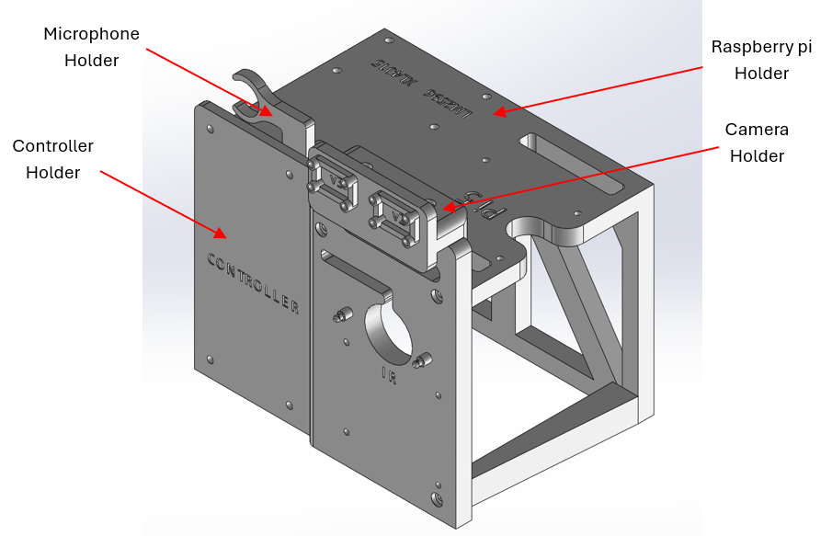
Figure 4.1: 3D model of the inner holder.
From Figure 4.1, the holder is designed to be small in size with a maximum dimension of $170mm×144mm×177mm$ to minimize the size needed for the outer case and minimize the overall weight. The holder has a modulated design for ease of maintenance. The holder consists of 4 separate parts: a cameras holder, a microphone holder, a raspberry pi holder and a controller holder. Each individual holder is securely connected together with bolts to allow ease of disassembly, modifications or replacement of an individual holder in the future.
The holder is designed to fully expose all components to the air, promoting airflow for enhanced heat dissipation. Its final weight is approximately $577g$.

Outer Case
The outer case is built to enclose all components, including the inner holder, ensuring protection against external impacts. The casing comprises two parts: the main case and the case cover. A rubber gasket is placed between them, and bolts are used to secure the case, ensuring waterproof protection. Figure 5.1 shows the 3D model of the outer case in isometric view.
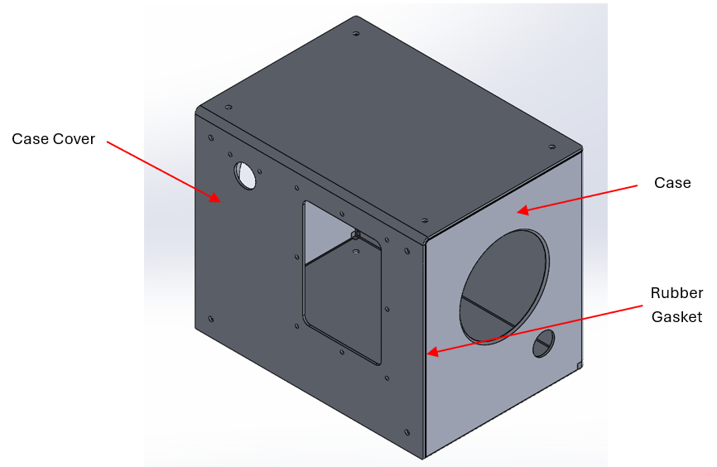
Figure 5.1: 3D model of the outer case.
From Figure 5.1, the outer case is designed to hold the inner case and the components while having clearance for vent, sensors, wires and bolts. The maximum dimensions of the outer case are $233mm×165mm×195mm$ with an inner capacity dimension of $229mm×160mm×190mm$ which is able to fit in the inner holder and other components. The outer case is manufactured from two aluminum sheets and folded accordingly as shown in the flat view of the aluminum sheets in Figure 5.2.
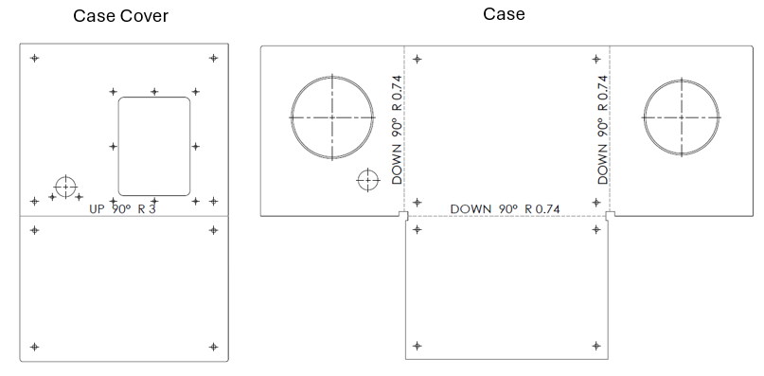
Figure 5.2: Case and case cover in flat view.
As illustrated in Figure 5.2, the case cover features a single $90°$ folding line, while the case has three. The two edges formed after folding will be joined through welding to ensure strong adhesion and an effective seal.

Final Assembly
Figure 6.1 shows the isometric view of the 3D model of the device with all the components mounted to the device including vent, fan, microphone cover, sensors, raspberry pi 5, etc.
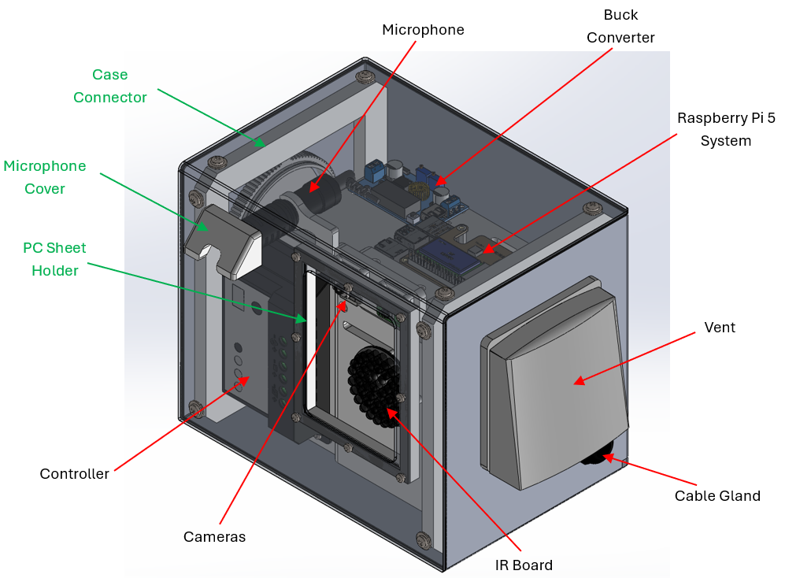
Figure 6.1: 3D model of the final assembly.
From Figure 6.1, the components labelled in green are 3D printed parts. The final maximum dimension of the device is approximately $308mm×194mm×203mm$ with an estimated weight of $4.2kg$. Figure 6.2 shows that exploded view of the device.
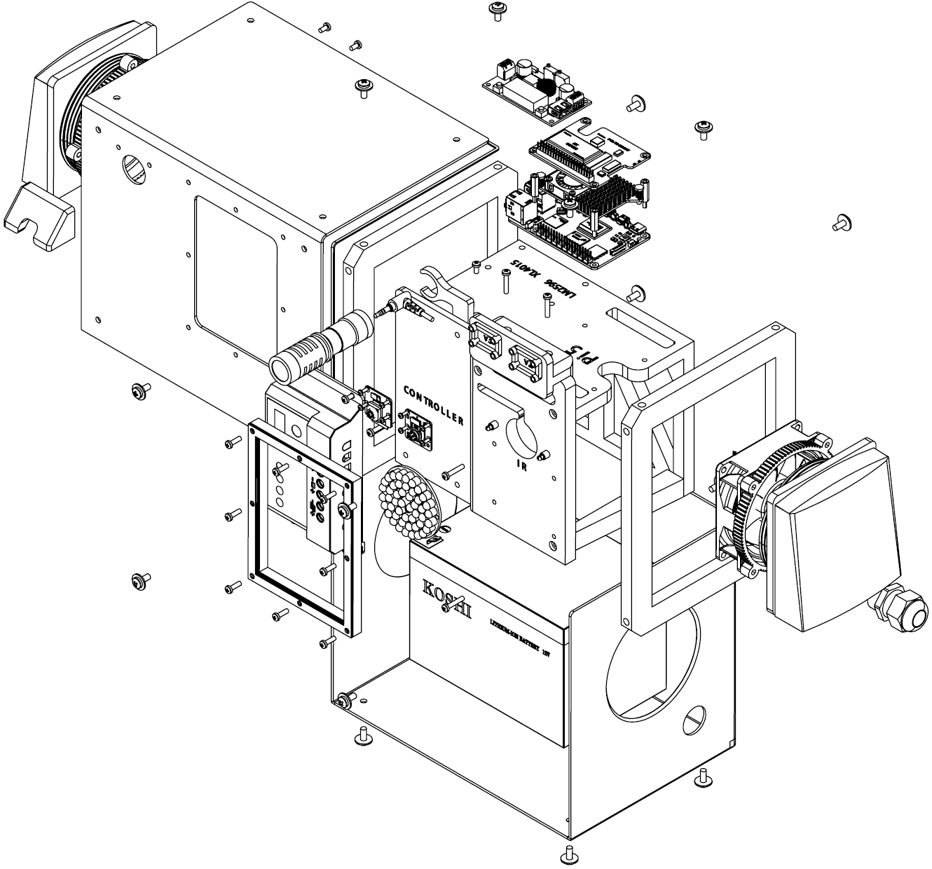
Figure 6.2: Exploded view of the device.
The IPV-1116 vent from Bud Industries is used to provide waterproofing while allowing airflow. To enhance ventilation, an 80mm × 80mm Sunon EF80251S1-1000U-A99 fan is mounted to one of the vents. This fan has an airflow rate of 1.15 m³/min, a low power consumption of 1.44W, and generates approximately 33dB of noise, which must be considered since a microphone is mounted inside the case.
For waterproof sealing, a neoprene rubber sheet is used as a gasket between the case and the case cover. A cable gland ensures waterproofing for wires passing through the casing, such as the solar cable. Additionally, rubber washers are used with bolts to further enhance waterproofing.

Design Studies
Design studies are carried out to verify that the outer case can support the system’s weight and withstand external impacts. It must successfully pass the drop test and exceed the required safety factor under the specified load.

7.1 Static Study
The case, including the case cover and connectors, is assembled and prepared for a static study in SolidWorks. The total mass of the components it must support is approximately 3.48 kg, resulting in a weight of 34.15 N. Two studies are conducted: one applying a 34.15 N force and another with a 50 N force toward the base of the case with different thickness. The key results analyzed are the maximum deformation (displacement) and the factor of safety (FOS). The ideal condition is to maintain displacement below 25% of the thickness while ensuring a FOS greater than 2. Figure 7.1.1 shows the 3D model of the case with force and fixture defined.
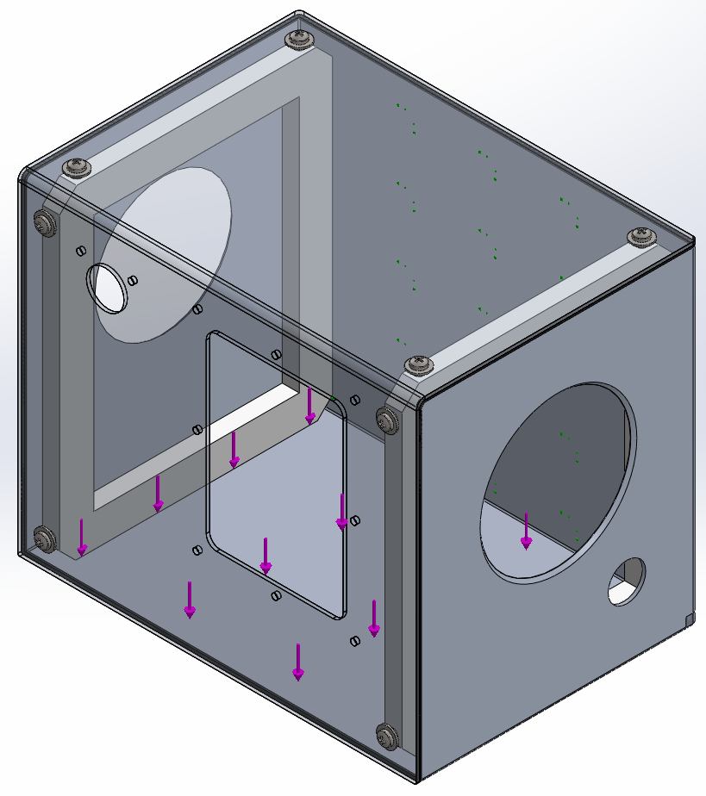
Figure 5.1.1: 3D model prepared for static study.
From Figure 7.1.1, the force is set downward toward the base of the case and the fixture is set at the back of the case. Figure 7.1.2 shows the graph of the results of static studies for both scenarios with different thickness of the outer case.
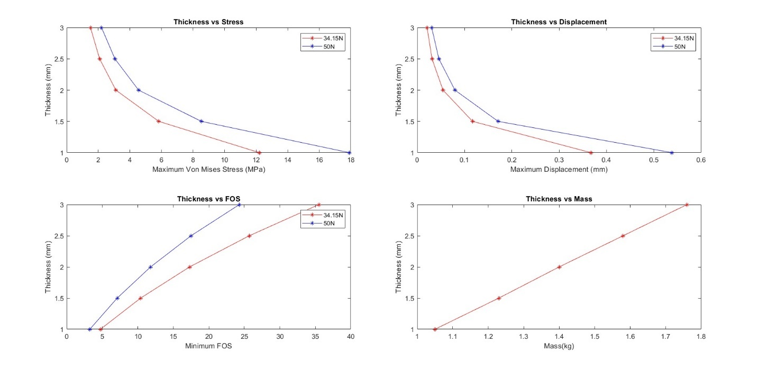
Figure 7.1.2: Graph of the results from static studies
As shown in Figure 7.1.2, increasing thickness enhances the case's ability to withstand the load, resulting in a higher FOS and reduced displacement. However, the final thickness selection must consider supplier availability while maintaining a balance between minimal weight, minimal displacement, and reasonable FOS. To meet the requirement of the total weight of $3-5kg$ while ensuring minimal displacement and a high FOS, a 2mm thick 6061 aluminum alloy sheets have been selected.
With a 2mm thick 6061-O aluminum alloy, the outer case can withstand a maximum load of approximately 300N, resulting in a displacement of 0.48mm and a FOS of 1.97. This indicates that the case can support up to 30kg before exceeding the acceptable displacement and FOS limits.

7.2 Drop Test

Financial
The total budget allocated to this project is RM$2000$. The development of the device that needs budget is split into 4 parts: Electronic components (sensor, microprocessor, etc.), case, power system, others (wires, bolts, nuts, vents, etc.). Table 8.1 shows the BOM of the components purchased for the device.
Table 8.1: BOM for components purchased for the device.
No. | Item | Variation | Supplier | Unit Price | Qty. | Total Price
1 | Raspberry Pi 5, 8GB | Mainboard | Cytron | RM369.00 | 1 | RM369.00
2 | Camera Module 3 | 12MP NoIR | Cytron | RM175.00 | 1 | RM175.00
3 | Heatsink & Active Cooler | - | Cytron | RM29.90 | 1 | RM29.90
4 | Raspberry Pi M.2 HAT | PCIe M.2 HAT + MakerDisk 256GB | Cytron | RM215.50 | 1 | RM215.50
5 | FPC 22-Way to 15-Way for Camera | 30cm | Cytron | RM9.90 | 2 | RM19.80
6 | USB to 3.5mm Audio Adapter - TRRS | - | Shopee | RM32.86 | 1 | RM32.86
7 | Microphone | Boya by mm1 | Shopee | RM81.62 | 1 | RM81.62
8 | Solar Panel | 50W | Shopee | RM91.38 | 1 | RM91.38
9 | Battery 18AH |  | Shopee | RM184.79 | 1 | RM184.79
10 | Solar Controller |  | Shopee | RM14.10 | 1 | RM14.10
11 | 5 METER Solar Cable | 2.5mm | Shopee | RM24.63 | 1 | RM24.63
12 | Bolts, Nuts and Insert |  | Cytron | RM26.46 | 1 | RM26.46
13 | Filaments | PETG | Cytron | RM55.00 | 1 | RM55.00
14 | DC Current Sensor |  | Cytron | RM29.00 | 1 | RM29.00
15 | Fan Axial 12VDC Wire | 80x25mm | DigiKey | RM27.55 | 1 | RM27.55
16 | IPV Ext Vent |  | DigiKey | RM28.35 | 2 | RM56.70
17 | Cable Gland M20 | 6 - 12mm | DigiKey | RM3.28 | 1 | RM3.28
18 | Washer Flat | M4 | DigiKey | RM0.20 | 25 | RM5.09
19 | Battery Connector | 6.35mm | DigiKey | RM0.28 | 10 | RM2.79
20 | Aluminum Sheet | 550mm x 600mm | Shopee | RM135.00 | 1 | RM135.00
21 | USB Type C |  | Cytron | RM8.00 | 1 | RM8.00
22 | Neoprene Rubber Sheet | 1.5 x 600 x 600mm | Shopee | RM14.00 | 1 | RM14.00
23 | PC Sheet | 1 x 1000 x 1000mm | Shopee | RM7.00 | 1 | RM7.00
24 | IR Infrared LED Board | 940nm 48pcs | Shopee | RM14.04 | 1 | RM14.04
25 | Cargo Strap Belt |  | Shopee | RM10.90 | 1 | RM10.90
26 | 4G dongle |  | 3D Smith | RM30.00 | 1 | RM30.00
27 | Y Branch Solar Cable |  | Shopee | RM16.57 | 1 | RM16.57
28 | Solar Panel | 50W | Shopee | RM85.00 | 1 | RM85.00
29 | Mount Bracket |  | Shopee | RM100.00 | 1 | RM100.00
30 | Raspberry Pi 5, 8GB |  | PRECOMP | RM410.00 | 1 | RM410.00
From Table 8.1, the total cost of components amounted to approximately RM2275, exceeding the original budget by RM275. Table 8.2 provides a breakdown of the budget allocation for each category alongside the actual spending.
Table 8.2: Budget allocation and spending for each category.
Category | Sensors | Case | Power | Others | Total
Budget | RM1000.00 | RM200.00 | RM300.00 | RM500.00 | RM2000.00
Total Spending | RM1324.16 | RM190.00 | RM491.84 | RM268.96 | RM2274.96
As shown in Table 8.2, the expenditure for the sensors and power categories exceeded their initial allocations. Initially, with some budget surplus, we decided to purchase an additional solar panel and a mounting bracket to maximize the use of the available funds and enhance the reliability of the system. However, unforeseen circumstances arose when the Raspberry Pi 5 initially purchased became faulty and malfunctioned. This necessitated the purchase of a replacement Raspberry Pi 5, which pushed the overall spending beyond the planned budget.
Despite this setback, it is important to note that without the replacement of the Raspberry Pi 5, the project would have remained realistic within the original RM2000 budget allocation. This scenario will be further reflected and addressed under the risk management section. High-cost critical components, such as the Raspberry Pi 5 and the PCIe M.2 HAT with SSD, naturally consumed a large portion of the budget, highlighting their importance to the system’s operation. Additionally, certain materials, including the neoprene rubber sheet and polycarbonate (PC) sheet, were purchased in larger quantities than required due to supplier packaging constraints. Nevertheless, these surplus materials can be repurposed for future projects, offering added value beyond the current scope.

Image Detection Accuracy
The training took approximately 20 hours to complete $500$ epochs. The mean average precision (mAP50) matrix is calculated at an Intersection over Union (IoU) threshold of 0.50, serving as a key metric to evaluate the model's accuracy [3]. The final average accuracy of the image detection model is approximately $84\%$. Figure 9.1 shows the plot of accuracy of the image detection model.
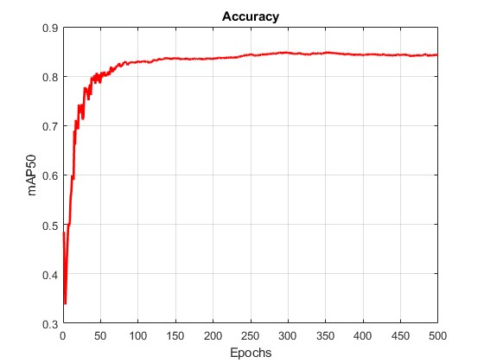
Figure 9.1: Accuracy of the image detection model.
As shown in Figure 9.1, overall accuracy stabilizes between 82% and 84% after the 350th epoch of training. However, as illustrated in Figure 9.2, the model achieves 95% accuracy in detecting elephants.
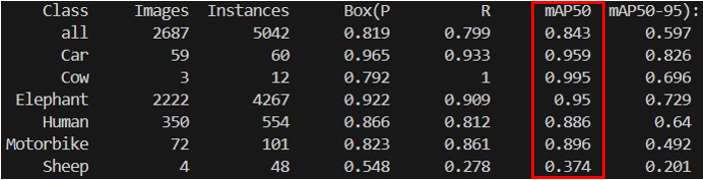
Figure 9.2: Accuracy of individual class.
As shown in Figure 9.2, the accuracy is high for all classes except for sheep, primarily due to dataset inconsistencies. The sheep class has a limited number of images, and its annotations are inaccurate. By excluding the sheep class, the average accuracy of the image detection model can reach 94%. The confusion matrix offers a detailed representation of the model's performance, displaying the counts of true positives, true negatives, false positives, and false negatives for each class [3]. Figure 9.3 shows the normalized confusion matrix of the image detection model.
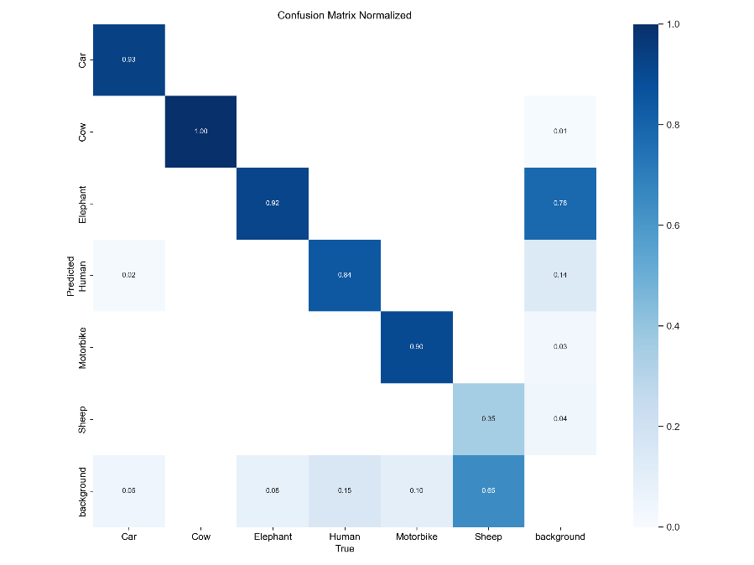
Figure 9.3: Normalized confusion matrix of the image detection model.
Figure 9.3 shows high true positive values for all classes except the sheep class, aligning with the accuracy trends observed in the mAP50 matrix. This model is saved and is implemented into the device. This trained model version is saved and implemented into the device. It can also be retrained in the future to enhance accuracy or incorporate additional classes.

Unforeseen Challenges and Time Delays
During this project, several tasks were not completed within the planned timeframe due to unforeseen circumstances. One of the primary causes of the delay was the late finalization of requirements, particularly those affecting the required capacity of the casing. This uncertainty prevented the casing design from proceeding as scheduled, leading to further postponements in finalizing the design. Additionally, delays in obtaining quotations and shipping from suppliers slowed the procurement process, affecting the overall project timeline. Since certain design and assembly tasks relied on obtaining and testing the components, these delays created a bottleneck in the workflow.
The impact of these delays was significant, resulting in a compressed schedule for critical tasks in March and April 2025. The initial project timeline had to be adjusted, leading to a more intensive workload towards the final stages. Some trade-offs had to be made, such as reducing the number of iterations for testing or limiting design modifications for both hardware and software to ensure the project stayed within the deadline. The accumulation of delayed tasks placed additional pressure on the final phases of development, affecting efficiency and testing time. Table 6.2.2.1 shows the approximate delay in weeks for the end of each stage.
Table 6.2.2.1: Approximate delay in weeks for the end of each stage.
Stages | Estimated Week of ending of stage | Approximated Weeks of Delay
Research and Requirements Finalization | Week 9 | 20
Logistics and Procurement | Week 12 | 4
Development | Week 25 | 2
Testing and Validation | Week 26 | 2
Assembly | Week 26 | 2
Documentation | Week 30 | 0
To reduce the effects of these delays, several adjustments were made. Tasks were prioritized based on their urgency, and wherever possible, multiple tasks where processing parallelly. These challenges highlighted valuable lessons for project management. One key takeaway is the importance of early planning and risk assessment, particularly in areas dependent on 3rd parties. Future projects should include buffer time to accommodate unexpected delays and implement proactive strategies to minimize disruptions. By improving efficiency in procurement, design finalization, and task management, similar setbacks can be better managed or avoided altogether in future developments.

Results and Discussions

11.1 Casing Design
During the assembly of the components, holders, and casing, all parts successfully fit within the enclosure. However, the outer case design posed challenges when mounting the device to a tree using a cargo strap. While mounting is still possible, the available space for positioning the strap is limited due to the clearance required for the cameras. Additionally, the ventilation openings occupy a significant portion of the case's sides. Future improvements to the casing design should focus on enabling easier and more secure mounting to a tree.
The internal layout remains compact after all components are installed, effectively minimizing internal movement during transportation and helping to protect the components from potential damage. While the routing of thick cables from the battery and solar charge controller is tight due to limited space, it was still managed successfully.
Initially, the 4G dongle was intended to be mounted on top of the main component holder. However, the surrounding aluminum casing was found to interfere with signal strength. As a temporary solution, the dongle was repositioned to the side of the holder, closer to the ventilation area, to improve connectivity.

11.2 Waterproofing
The assembled casing demonstrates a good level of waterproofing, providing effective protection for the internal components against rain and moisture. A key feature of the design is the use of a vent cover that shields the ventilation openings, preventing rainwater from entering from various directions. Similarly, the microphone is protected by a dedicated cover that offers basic rain resistance. However, it is noted that under conditions of heavy rain, the microphone cover may not offer sufficient protection, posing a risk of water ingress. Future improvements are necessary either by enhancing the current mic cover design or by relocating the microphone to a more sheltered position within the casing to ensure better waterproofing performance.
To further improve waterproofing, a rubber sheet was installed between the contact surfaces of the case and its cover, acting as a gasket to prevent water from seeping inside. While this approach is largely effective, minor issues were observed. Due to tolerance variations introduced during the manual bending process of the aluminum casing, some unevenness exists at the contact surfaces. This misalignment has resulted in areas where the rubber gasket does not seal perfectly, creating potential leakage points. An initial solution to address this issue involved applying soft silicone at the uneven sections to improve the seal locally.
Looking ahead, a more robust solution would involve replacing the current rubber sheet with a softer, more adaptable material. Using a softer gasket material could better accommodate minor surface irregularities and provide a more consistent seal around the casing, ultimately enhancing the overall waterproofing reliability. This adjustment would ensure that the device remains resilient even under harsher weather conditions, such as prolonged heavy rainfall.

Conclusion and Future works

12.1 Casing Design
While the current casing design successfully protected the device's internal components and provided sufficient environmental shielding, several opportunities for enhancement have been identified. The compact internal layout minimized component movement, and the casing generally resisted rain exposure during testing. However, specific challenges related to mounting flexibility, waterproofing consistency, and manufacturing precision point toward necessary improvements for future iterations.
One of the primary areas for improvement is the mounting system. The current reliance on external cargo straps is limited by clearance constraints around the casing, especially due to camera placement and vent positioning. A future design could integrate molded strap channels or fixed mounting brackets into the casing structure, allowing for faster, more secure attachment to various surfaces without interfering with the components' field of view. Considering adjustable or modular mounting options would also improve the adaptability of the device to different field deployment conditions.
Enhancing waterproofing performance is another critical focus area. While the existing rubber gasket provides reasonable protection, inconsistencies caused by manual bending during manufacturing created slight misalignments at the sealing surfaces. A softer, more flexible gasket material could be introduced to better conform to surface irregularities, ensuring a more reliable seal. Additionally, critical areas such as the microphone housing require design revision; using waterproof acoustic membranes or relocating the microphone to a more sheltered internal compartment would significantly improve rain resistance without compromising sound detection capabilities. Incorporating these changes would not only increase durability but also reduce the maintenance required during long-term outdoor deployments.

12.2 Waterproofing
The casing design achieved a satisfactory level of waterproofing, providing essential protection for internal components during deployment. Key design features such as the vent cover and microphone cover contributed to shielding the device from rain exposure. The addition of a rubber sheet between the casing and its cover further enhanced water resistance by acting as a barrier against potential ingress. Overall, the casing maintained reliable protection under normal weather conditions.
However, several areas for improvement were identified. In particular, the microphone cover may not offer sufficient protection during heavy rainfall, and further refinement or repositioning of the microphone is necessary to enhance its resilience. Additionally, minor surface irregularities caused by manufacturing tolerances affected the effectiveness of the gasket seal. Addressing these issues could involve applying soft silicone at critical points or adopting a softer gasket material that conforms better to surface imperfections. These improvements would strengthen the waterproofing performance and ensure the device remains durable and reliable across a wider range of environmental conditions.

API
The device communicates with the website through an API for two main purposes. First, it performs a periodic handshake with the server at one-hour intervals to confirm that the device remains active and operational. This regular handshake mechanism allows users to monitor the device’s status in real time through the website. Second, the device sends detection data via the API whenever an event is recorded. Each detection event generates a payload containing relevant information such as the image file, audio file, timestamp, and the confidence levels for both image and audio detections.
To ensure security and proper authorization, each device is registered with a unique device name and API key. These credentials authenticate the device and ensure that only authorized devices can interact with the API. On the user side, access to the detection data through the website is restricted to registered users, further safeguarding the integrity and confidentiality of the data collected.
The reliability of data transmission largely depends on the quality of the network connection. To accommodate field deployments where Wi-Fi may not be available, a 4G dongle is used to provide mobile internet access. In scenarios where network connectivity is poor, the device is programmed to attempt resending the detection data up to three times. If all upload attempts fail, the unsent detection data is saved into a designated folder on the device. The data will not be automatically uploaded once the connection is restored; instead, it can be manually extracted by personnel during scheduled maintenance visits to the device, which may occur every few months. Additionally, a comprehensive logging system is implemented to record all major events, including successful handshakes, data transmissions, warnings, errors, and the saving of unsent detections. This logging feature plays a crucial role in troubleshooting and monitoring device performance over time.

Proposed Design of Commercial Product
To transition from a functional prototype to a deployable commercial product, several key enhancements should be implemented. These improvements aim to increase the system’s performance, reliability, ease of deployment, and suitability for long-term operation in remote or harsh environments. The following subsections outline proposed design features for a commercial version of the elephant detection system.

14.1 Enhanced Power Generation
A commercial system would benefit from a significantly upgraded power generation set up. The integration of higher-capacity solar panels, preferably 100W or more, would ensure continuous operation even during periods of low sunlight. This would be complemented by larger battery banks, enabling the device to function reliably during nighttime or cloudy days. Additionally, power efficiency can be further optimized by using low-power microcontrollers and peripherals that consume minimal energy during idle or low-activity periods. Incorporating intelligent power management systems could also allow for adaptive power distribution, conserving energy during non-critical periods while prioritizing high-consumption tasks like real-time data transmission during detection events.

14.2 Improved Detection System
The commercial version could utilize more robust and scalable detection systems by leveraging advanced machine learning models, either deployed on edge devices or processed through a hybrid edge-cloud architecture. This would allow for dynamic updates to the detection algorithms without needing physical access to the system. Real-time model improvement could be achieved through cloud-assisted learning, further increasing detection accuracy and reducing false positives. Moreover, combining multi-modal sensory inputs, specifically synchronizing camera-based visual detection with audio analysis, would allow for cross-verification and more confident event classification. This fusion approach would increase reliability in diverse environmental conditions where one modality might fail due to noise, occlusion, or lighting.

14.3 Remote Connectivity
For commercial deployment in remote or undeveloped regions, the system must maintain consistent and reliable connectivity. Satellite communication systems or integration with low-power wide-area networks (LPWAN), such as LoRaWAN, would enable the device to transmit critical alerts and system status data without depending on mobile data coverage. This ensures real-time communication even in isolated areas with poor cellular reception. These connectivity solutions would also enable remote firmware updates, device health monitoring, and coordinated detection across multiple units.

14.4 Scalability and Networking
A key feature of the commercial product would be its ability to scale. A distributed network of detection units could be deployed across large geographical regions, communicating through a mesh network architecture. These units would relay data to a centralized server or control center, allowing broader area coverage and collaborative event tracking. This interconnected structure allows flexible deployment configurations, efficient use of resources, and redundancy in case one unit fails. By integrating GPS modules, the system could also offer geolocation tagging of detections, aiding conservationists in mapping wildlife movement patterns over time.

14.5 Durability and Design
To ensure resilience in real-world environments, the commercial system should be housed in a robust and tamper-resistant enclosure. The casing must be weatherproof to protect internal electronics from rain, dust, and temperature extremes. The outer casing should be fabricated from durable aluminum, offering structural integrity and corrosion resistance, while internal components such as holders can continue to utilize lightweight 3D-printed materials to reduce the overall system weight. The design should prioritize modularity to ease maintenance and allow for straightforward assembly and disassembly during deployment or servicing. These improvements in casing materials and construction would significantly increase the device’s lifespan and reliability in outdoor field conditions.

14.6 Security and Data Protection
For commercial deployment, securing both the hardware and transmitted data is crucial, particularly when dealing with sensitive wildlife detection information and network-connected devices. The system should implement secure communication protocols such as HTTPS and token-based API authentication to prevent unauthorized data access. Data collected on the device, including images and audio clips, should be encrypted locally to prevent misuse in the event of physical tampering or theft. To enhance physical security, tamper-evident seals or intrusion sensors could be added to the enclosure to alert administrators of any unauthorized access attempts. Additionally, periodic key rotation and access logging should be employed on the server side to ensure long-term protection against cyber threats.

14.7 Cost Optimization
Cost efficiency can be achieved through strategic sourcing of components in bulk, use of standardized parts, and streamlining the design to reduce assembly complexity. Alternative materials may be explored for non-critical parts to further lower production costs. By balancing performance, cost, and scalability, the system can be made more accessible to organizations with varying budgets while maintaining the quality required for long-term deployment.

References

[1] | P. Jiang, D. Ergu, F. Liu, Y. Cai and B. Ma, "A Review of Yolo Algorithm Developments," Procedia Computer Science, pp. 1066-1073, 2022.
[2] | U. Sirisha, S. P. Praveen, P. N. Srinivasu, P. Barsocchi and A. K. Bhoi, "Statistical Analysis of Design Aspects of Various YOLO-Based Deep Learning Models for Object Detection," International Journal of Computational Intelligence Systems, vol. 16, 2023.
[3] | ultralytics, "Performance Metrics Deep Dive," ultralytics, 12 11 2023. [Online]. Available: https://docs.ultralytics.com/guides/yolo-performance-metrics/#how-can-validation-metrics-from-yolo11-help-improve-model-performance. [Accessed 1 4 2025].
[4] | K. Szykiedans, W. Credo and D. Osiński, "Selected Mechanical Properties of PETG 3-D Prints}," Procedia Engineering, vol. 177, pp. 455-461, 2017.
[5] | K. D. Ragesh, N. Ganesh, S. Y. K. Reddy, H. Mishra and T. M. T. Naidu, "Experimental research on the mechanical characteristics of fused deposition modelled ABS, PLA and PETG specimens printed in 3D," Materials Today: Proceedings, pp. 1-9, 2023.
[6] | S. Hajifathaliha, "material, A sustainable approach in additive manufacturing with recycled," p. 43, 2017.
[7] | R. Kumar, H. Sharma, C. Saran, T. S. Tripathy, K. S. Sangwan and C. Herrmann, "A Comparative Study on the Life Cycle Assessment of a 3D Printed Product with PLA, ABS & PETG Materials," Procedia CIRP, vol. 107, pp. 15-20, 2022.
[8] | J. Davis, Metals Handbook, Desk Edition (2nd Edition), ASM International, 1998.
[9] | Z. Ahmad, "CHAPTER 10 - ATMOSPHERIC CORROSION," in Principles of Corrosion Engineering and Corrosion Control, Butterworth-Heinemann, 2006, pp. 550-575.

Appendixes

Appendix A: Dimensions for outer casing
